Teresa Żarnower [Żarnowerówna] (1895 Warsaw–1950 New York)
was a Polish painter, graphic artist, sculptor, and stage/architectural designer. One of the most prominent representatives of POLISH CONSTRUCTIVISM, Żarnower was also linked to the YIDDISH AVANT-GARDE and belonged to the pioneers of functional typography and photomontage. As co-founder and the main representative of the Polish group Blok, she edited the group’s magazine Blok (1924-26). Together with her closest collaborator, Mieczysław Szczuka, she made this publication a forum of INTERNATIONAL CONSTRUCTIVISM, promoting machine aesthetics and a utilitarian approach to art.

Career
Beginning in 1915, Żarnower studied sculpture at the School of Fine Arts in Warsaw; in 1919 she was awarded the prize for the best student of the year. She also received a prize by the Ministry of Art and Culture for her diploma work Masculine Nude (1920). Żarnower held her first exhibition in the Spring Salon of the Society for Fine Arts Promotion in 1921, and co-organised the Exhibition of New Art in Vilnius in 1923, as well as Blok group shows in Warsaw in 1924–25. She exhibited her works in the Berlin gallery Der Sturm (1923), at the International Exhibition of Modern Art in Bucharest (1926), at the first International Modern Architecture Exhibition in Warsaw (1926), and at the Modern Architecture Exhibition in Moscow (1927).

In her theoretical statement in the 1923 Vilnius catalogue, Żarnower called for simplicity and utilitarian qualities for new art. In her view, artists had to replace pure aesthetics, and anticipate the development of cinematic shows containing elements of painting, sculpture, architecture, poetry, music, film, and dance. She was most likely also co-author of the manifesto “What is constructivism?” in Blok (nos. 6-7).

At the beginning of the 1920s, Żarnower experimented with a style of abstract sculpture inspired by ALEXANDR RODCHENKO, and in the mid-1920s she began to use photomontage for political purposes, such as in left-wing posters. A well-known book designer, she prepared the layout for the publications by Ilya Erenburg and Vladimir Mayakovsky (1929) and worked with Yiddish editing houses designing the cover of Arbeter lueth (1926). In magazines such as Kuźnia (The Forge, 1927), Miesięcznik Literacki (Literary Monthly, 1929), and Czerwony Sztandar (The Red Banner, 1931), she developed the clear and strict style of her typographical compositions consisting of parallel and right-angled crossing lines.

After the death of Szczuka in 1927, she took over publication of the revue Dźwignia (The Lever) and devoted its 5th issue to his memory. She also honoured him in the bilingual book Europa, which featured typography by Szczuka and text by Anatol Stern (1929). This book was awarded a prize at the 1931 International Exhibition of Modern Books in Paris. While Żarnower’s dynamic photomontage for the cover of this publication delivers a grotesque analysis of the world at the end of the 1920s, her photomontage for the cover of the book Obrona Warszawy (The Defence of Warsaw, 1942), done in the same compositional style, depicts the catastrophe of the war.

In 1937, Żarnower emigrated to Paris, and during World War II she relocated to Spain, Portugal, Canada and finally to New York, where she worked on a monumental sculpture devoted to the Warsaw Ghetto uprising. In the 1940s she turned to painting for economic reasons, and until her suicide in 1950 she created some semi-figurative watercolours.

Legacy
Most art works by Żarnower are known only from reproductions in books and journals, mainly from illustrations in Blok. Barnett Newman wrote the foreword to the catalogue of her last exhibition, at Peggy Guggenheim’s Art of This Century Gallery in 1946.

References and further readings:

Barnett Newman, Selected Writings and Interviews, ed. by John P. O’Neill, New York: Knopf, 1990.

Constructivism in Poland, 1923-1936: Blok, Praesens, a.r., Lodz: Museum of Art, Essen: Folkwang Museum, Otterlo: Rijksmuseum Kröller-Müller, 1973.

Hilary Gresty, Jeremy Lewison (eds), Constructivism in Poland 1923 to 1926, Cambridge: Kettle’s Yard Gallery; London: Riverside Studios; Oxford: Museum of Modern Art 1984.

Natasza Styrna, Teresa Żarnower 1895–1950, http://jwa.org/encyclopedia/article/zarnower-teresa

The 70th Anniversary of the New Art Exhibition, Vilnius 1923, Łódź: Museum of Art, 1993, n.p.

Suggested images:

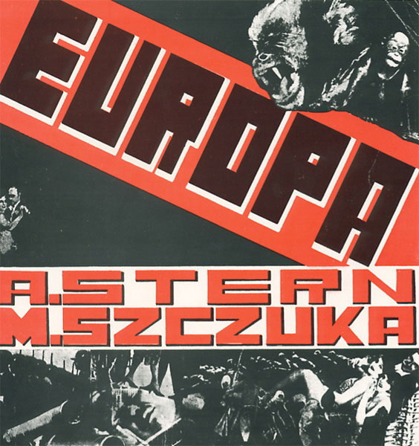
1. Teresa Żarnowerówna, cover for the book Europa with texts by Anatol Stern and design by Władyslaw Szczuka, Warsaw 1931, photomontage 1929, http://www.google.pl/imgres?q=Teresa+Zarnower&hl=de&sa=X&biw=1366&bih=6 36&tbm=isch&prmd=imvnsb&tbnid=26eslyCMMF1m4M:&imgrefurl=http://www.themersonarchive.com/book8.htm&docid=AEj98qeDWm8BVM&imgurl=http://www.themersonarchive.com/largepics/gaba8.jpg&w=564&h=600&ei=g3MJUK_7FaGa1AXk3vy0Cg&zoom=1

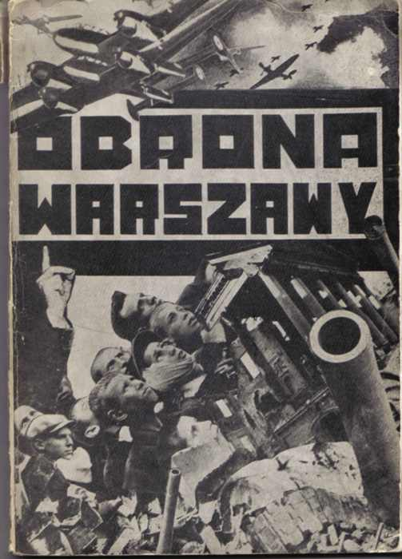
2. Teresa Żarnowerówna, Obrona Warszawy. Lud polski w obronie stolicy (wrzesień 1939 roku) [The Defense of Warsaw. Polish people in defense of the capital (September 1939)], New York: Polish Labor Group, 1942, Museum of Modern Art, Warsaw
http://www.google.pl/imgres?q=Teresa+%C5%BBarnower&hl=de&sa=G&biw=1366&bih=636&tbm=isch&tbnid=m6U605kegGO5CM:&imgrefurl=http://www.artmuseum.pl/kolekcja.php%3Fl%3D0%26id%3DZarnowerowna_obrona&docid=bkfpQuWjTfguXM&imgurl=http://www.artmuseum.pl/kolekcja/700px/96.jpg&w=503&h=700&ei=Ym4JUM2lOcKT0QXn6dGuCg&zoom=1

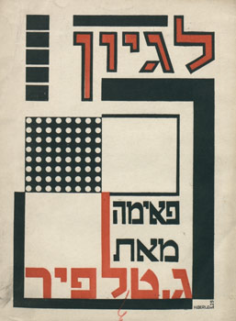
3. Teresa Żarnowerówna, cover design Arbeter Luekh, Warsaw 1926, Musée d’art et histoire du judaïsme, Paris
http://www.google.pl/imgres?q=Teresa+Zarnower&hl=de&sa=X&biw=1366&bih=636&tbm=isch&prmd=imvnsb&tbnid=Hs4HtnjmQi8isM:&imgrefurl=http://www.e-flux.com/announcements/sanja-ivekovic-and-pole-jew-artist-identity-and-avant-garde/&docid=BA2EXMsrc7E5yM&imgurl=http://www.e-flux.com/wp-content/uploads/2010/11/wpid-1255466902image_web.jpg&w=257&h=350&ei=q3QJUIiPDIXS0QXX1tzTCg&zoom=1

